**CSI3670**

**Winter 2021**

**Lab 5: IIS/MSSQL**

**Due date: March 28th @ 11:59pm**

**Synopsis**

Let’s create a wiki. Basic, I know, but it helps us learn how IIS works.

**Installation**

First things first, we need to install IIS and SQL Server. IIS is an easy install.

On your GCP Windows VM, open up your Server Manager Dashboard → 2 Add roles and features → Role-based or feature-based installation 🡪 Select your server 🡪 Add Roles → Web Server (IIS).

Recall that if you want to run an FTP server as well, you’ll need to check FTP Server (expand the Web Server (IIS) dropdown menu and you should see it). It’s not required for this lab but might as well install it anyway. Leave the default features, check the box to restart if required, and install your IIS server role.

Once that is installed, open up a browser (in your VM) and navigate to [http://localhost](http://localhost/). **Take a screenshot of the default web site and paste it in your lab report.**

Next we’ll install SQL Server Express edition. I’m going with Express because I’m not 100% that everybody can access the full version up on Microsoft. If you can, feel free to pull down the full version, but these instructions will focus on Express.

In your VM, go to this link: <https://go.microsoft.com/fwlink/?linkid=866658>

If you have the IE Enhanced Security Configuration on, you will need to disable it to run this file. You can either save the file or run it directly, but either way you’ll need to run it. Alternatively, you can search for SQL Server Express (we’re installing the 2019 edition). Note you'll need to enable File Downloads if you haven't.

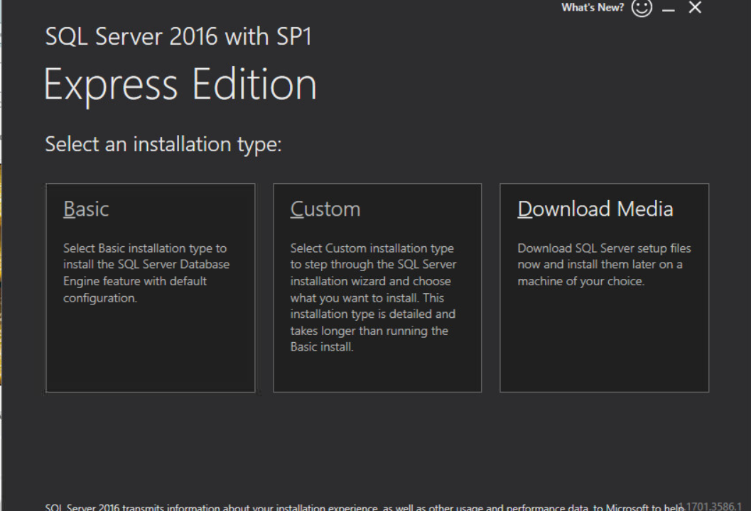

Select **Basic**, accept the license agreement, and accept the default installation location.

Click the Install SSMS button to download the management studio. Leave the default folders alone. Download SQL Server Management Studio (18.8) on the webpage that pops up and install.

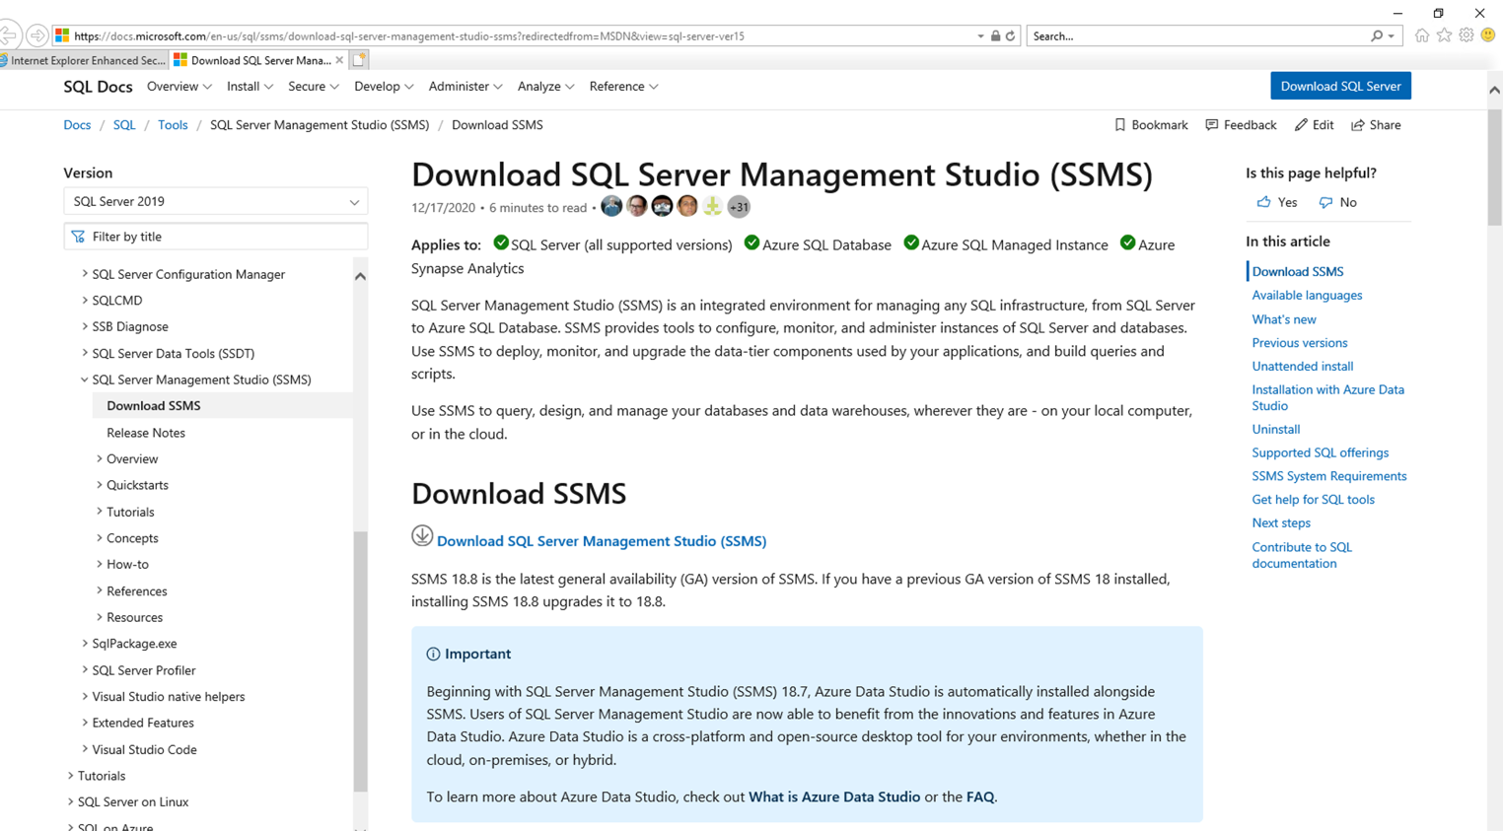

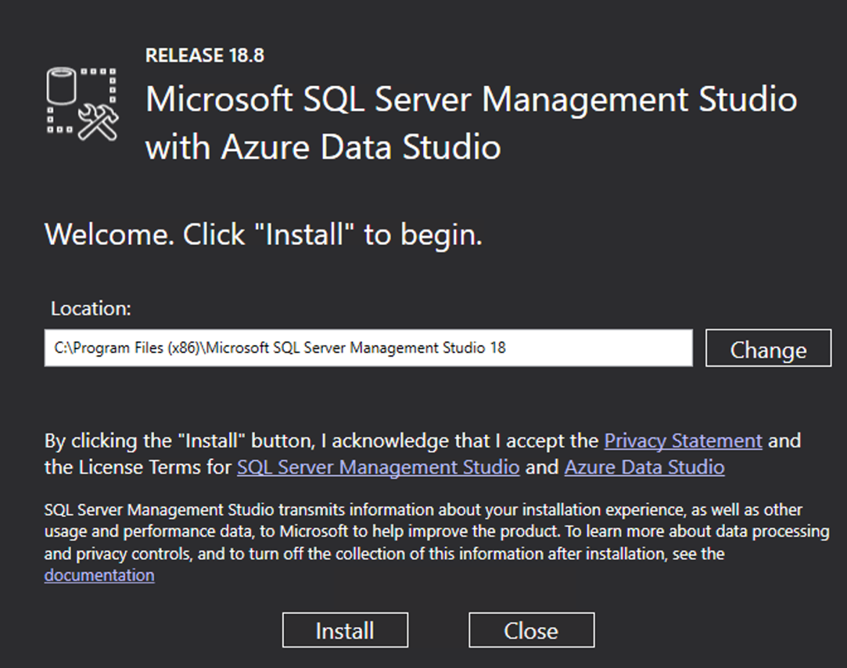

Once installation is complete, choose the option to restart your VM.

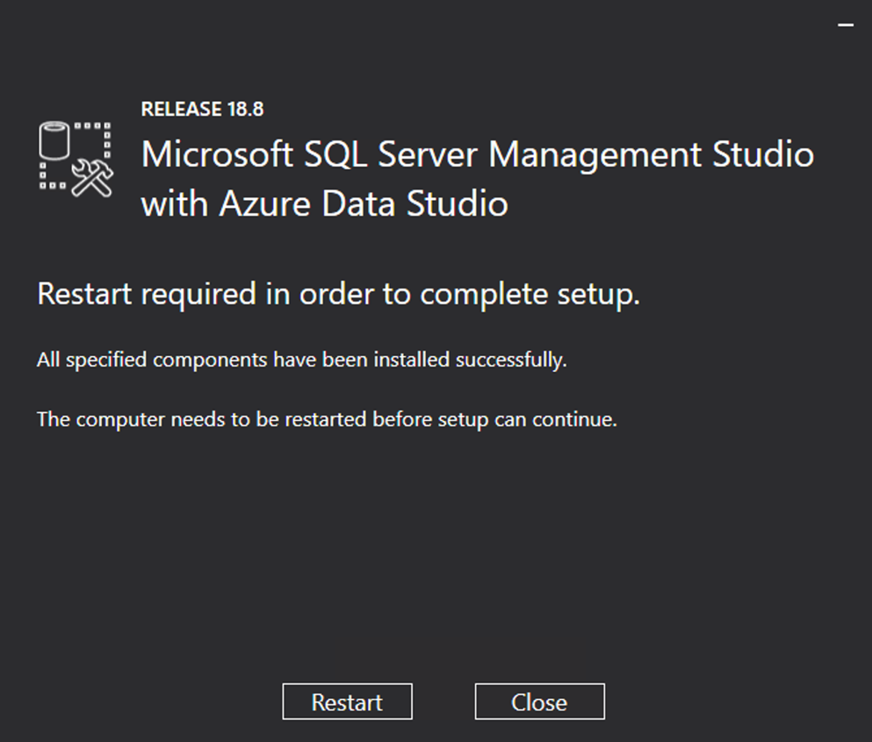

From the Start menu, open up the SQL Server Management Studio and connect to the default database.

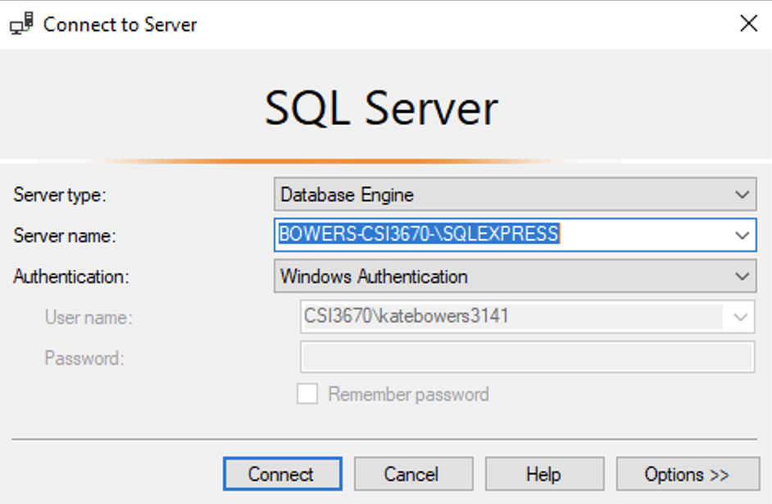

Now, we need to set a default password for the sa account.

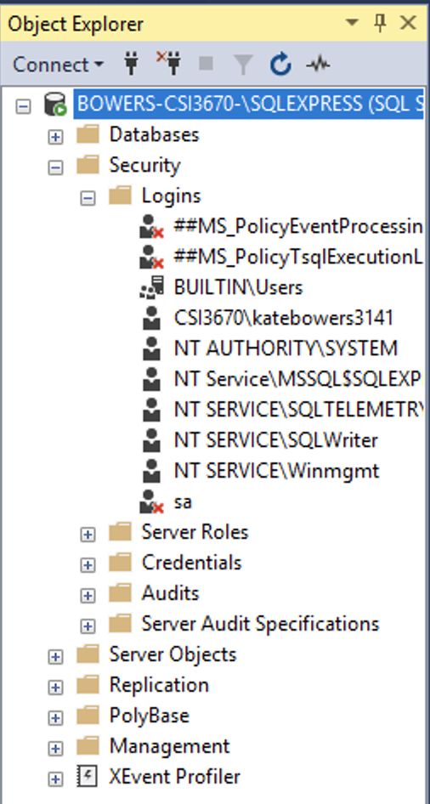

Right click on the sa icon under the Logins folder and select Properties. Change the password to Temp12345. Deselect 'Enforce Password Policy.' Under Status (top left pane) click 'Enabled' under Login. Click OK and the red X next to sa should go away.

Right click on the server at the top (mine starts with BOWERS-CSI…) and click Properties. Click Security. Set the server authentication to SQL Server and Windows Authentication mode. Click OK. Right click the top server again and restart the server.

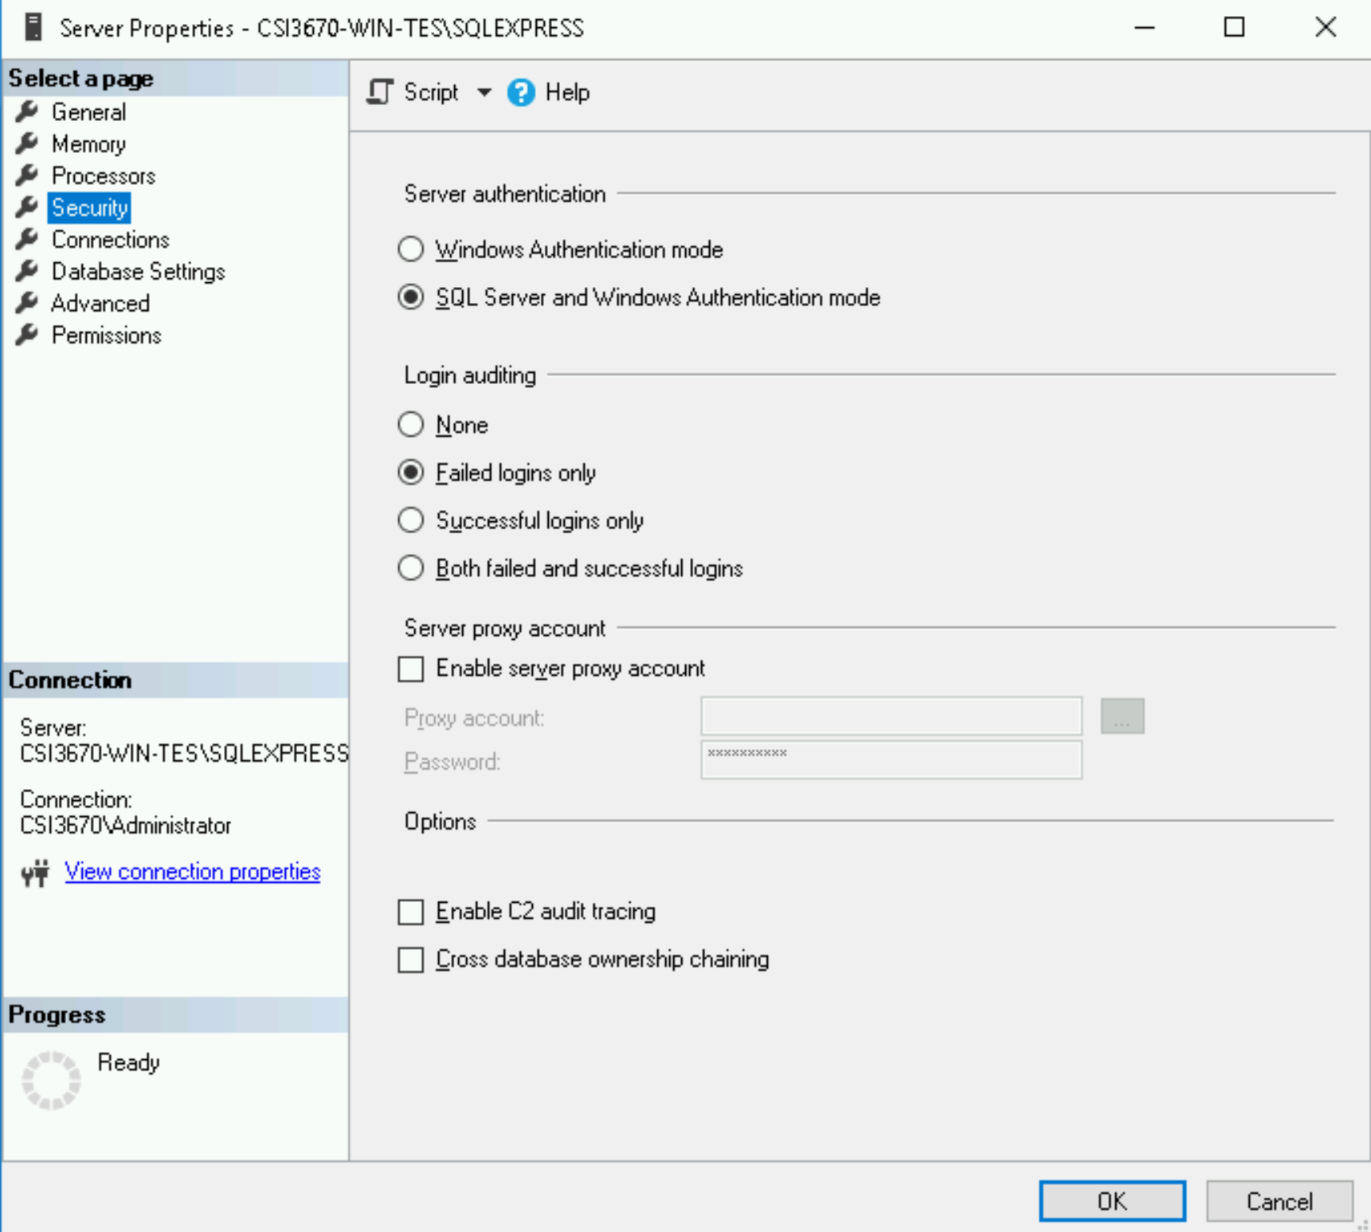

In your VM, download the Web Platform Installer here by clicking 'Install this Extension': <https://www.microsoft.com/web/downloads/platform.aspx>

From the Start menu, open the Web Platform Installer. Click the Applications tab, click Forum, then install **YetAnotherForum.NET**. You can also do this in IIS -> Web Platform Installer.

When the installer prompts you, provide your default password (Temp12345) and leave it at Default Site. Give it an application name of **YAF**. For password, once again set it to Temp12345.

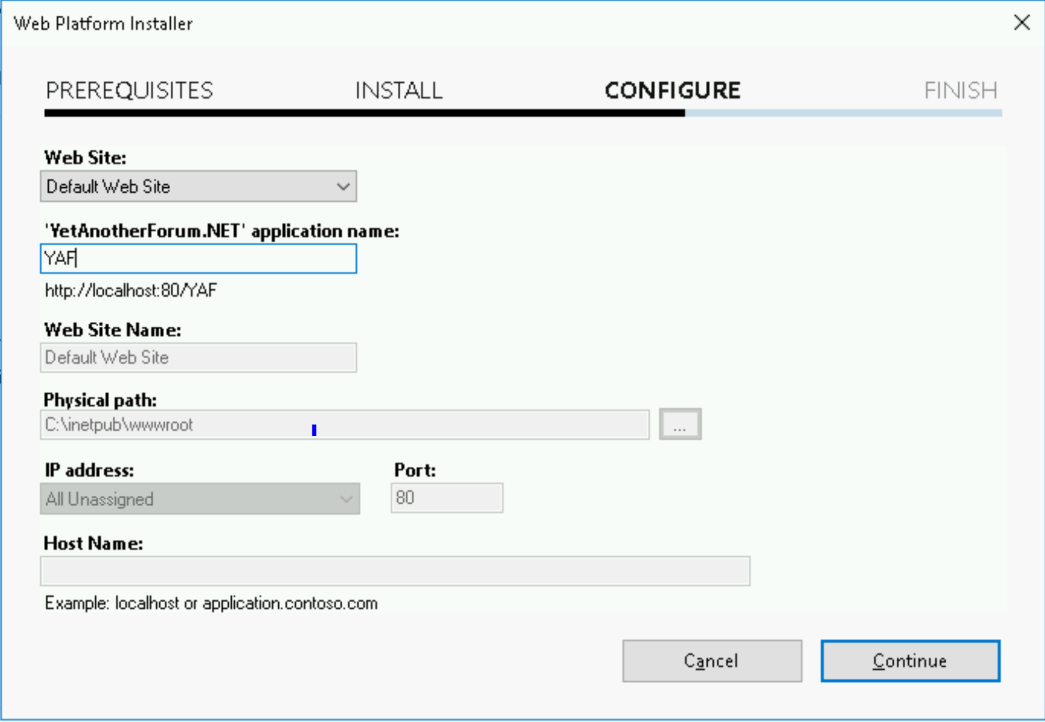

Now, browse to [http://localhost](http://localhost/)/YAF and let’s try to configure it.

Uh oh, you’ll probably see an ugly error message.

Go to your Server Manager, and at the top right, click on Tools 🡪 Internet Information Services (IIS) Manager. In the left pane of the window, navigate to Application Pools. Right click on YAF 🡪 Basic Settings 🡪 Change its .NET CLR version to 4.0.

Still an error if you restart your site.

Then, go back to your Server Manager page, navigate to the Add roles and features page. Under Server Roles. expand Web Server (IIS). Under the Web Server 🡪 Application Development, add a check under ASP.NET 4.7. Add all of the features associated with it when prompted. Install and restart your VM again. Navigate to the config page at http://localhost/YAF/install/default.aspx

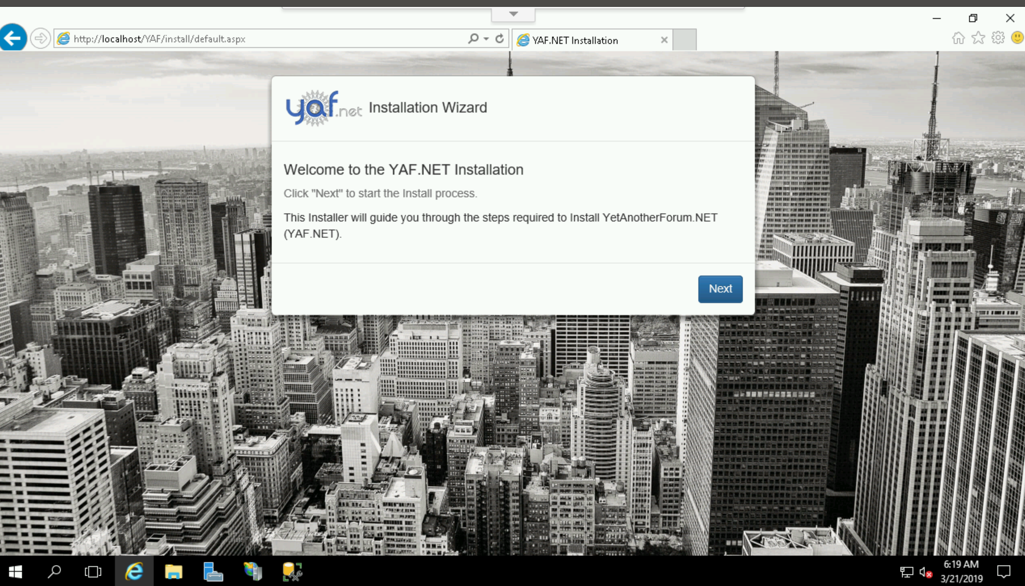

Walk through the configuration, clicking Next for everything and skipping the email settings.

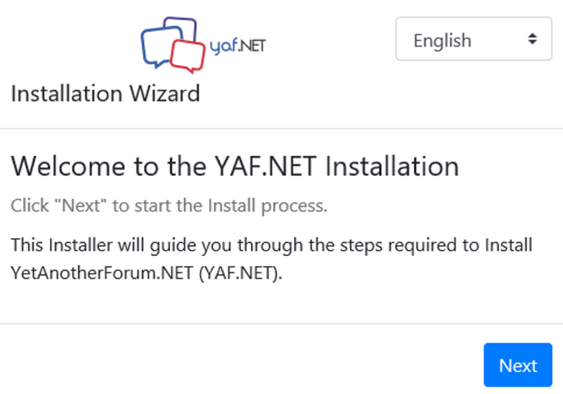

Add /YAF to the Base Url Mask.

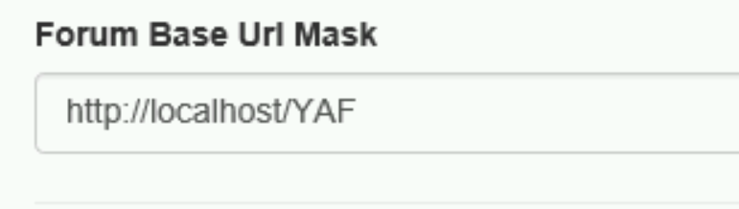

If you get 'The operation timed out' then just refresh. It *should* take care of it.

**Take a screenshot of the YAF homepage and paste it in your lab report to show that it’s working.**

**Lab Report**

Some of these questions will require Googling, but make sure to (1) cite your source and (2) rephrase in your own words. Other questions you may be able to find in the class slides under Web Server on Moodle.

1. What are two differences (**other than cost**) between SQL Server and SQL Server Express Edition?
2. What is a default website in IIS? If you wanted to create a new default website (not using the existing default website), what steps are required to do so?
3. Describe the differences between Digest, Forms, and Windows authentication for IIS applications/sites.
4. What is an application pool?
5. Assume that you wanted IIS to run PHP pages. What would you have to do in order to serve PHP content?
6. Create some subforums on your wiki and screenshot them. Make a sample post and screenshot that too.
7. Make sure all screenshots asked for (two from the lab walk-through, plus the two from Question 6) are pasted here.